**Unit 14 – Business Intelligence**

**B.I - Power B.I & SAP B.I**

**Benefits and drawbacks of application software as a mechanism for business processing**

horizontal line

# 

# Introduction

This report will analyse and evaluate the benefits and drawbacks of using application software as a mechanism for business processing. It also compares the tools and techniques associated with business intelligence functionally. This report will also discuss with specific examples and the key features of business intelligence functionality.

**What is Power B.I ?**

Power BI is a selection of software services, applications and plugins that function together to transform the disconnected data sources into cohesive, visually engaging and collaborative insights. The data can be an Excel spreadsheet or a series of cloud-based and on-site hybrid information warehouses. Power BI allows you to easily link to your data sources, imagine and explore what's relevant, and communicate it with anyone or anyone you choose.

**What is SAP B.I ?**

SAT BI (Business Intelligence) is a tool used by SAP applications to provide a company with a versatile way to share information that is available to the entire organisation. SAP BI encourages data to be exchanged in real time at all levels-from the Chairman to consultants from senior executives to low-level employees-allows better decision-making in an enterprise.

**Parts of Power B.I ?**

Power BI consists of:

* A Windows desktop application called Power BI Desktop.
* An online SaaS (Software as a Service) service called the Power BI service.
* Power BI mobile apps for Windows, iOS, and Android devices.

Power BI is

* a Windows desktop software called Power BI Computer.
* The online service SaaS (Software as a Service) calls the Power BI service.
* Mobile Power BI applications for Windows, iOS and Android smartphones.

These three elements — Power BI Cloud, Server, and Mobile Apps — are designed to help you develop, distribute, and access market knowledge in the way that best suits you and your job.

The fourth component, Power BI Report Server, helps you to post Power BI documents to an on-site report server after you have generated them in Power BI Desktop. Write more on the Power BI File Archive.

**How Power B.I matches your role ?**

How you use Power BI can rely on your position in the project or on your team. Some individuals, in other positions, might be using Power BI differently.

For example, you can mainly use the Power BI software to display reports and dashboards. Your number-crunching, business-report-creating coworker could make extensive use of Power BI Desktop to generate documents, and then post those reports to the Power BI system where you access them.

If you are a programmer, you may be able to use Power BI APIs to transfer information into databases or to insert dashboards and analyses into your own custom applications. Have you got an idea for a new visual? Create it on your own and share it with others.

**Why Use Power B.I ?**

In July 2015, the BI device was released. New features have been launched constantly in order to improve this. Since its first update, key features such as PowerPivot, PowerView and Power Query have been retained in the development of the tool.

Among the revised apps are different visualisations. With the launch of its own powerbi.microsoft.com website and its own model for the development of dashboards, the Power BI platform is separate from Office 365 and Excel.

Exploring Power BI information for fast analysis is a popular use case for many consumers. Further specialised usages of natural language or real-time data often come within the skill range.

Exploring Power BI knowledge for quick analysis is a famous use case for many customers. Certain special cases of use of natural language or real-time data also come within the ability spectrum.

**Magic Quadrant for Business Intelligence and Analytics Platforms**

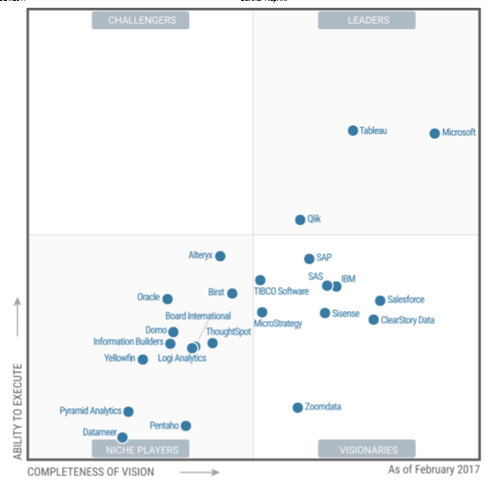

**1. Target Audience — The Users And Decision Makers**

The programme addresses all classes of customers, spanning from inexperienced, medium and experienced consumers, with features designed to match all levels of experience. For example, data analysts can use it to extract detailed performance analysis for action to be taken.

Business users also use it to track shifts to information trends in order to understand the quality of their expenditures in promotions, revenue and advertisement.

Developers may integrate software diagrams and documents into their ad hoc or front-end applications.

**2. Key Features — The Unique Selling Points**

The key features in Power BI graphics and monitoring include:

the development of live data dashboards. We can be produced in just five minutes. This software provides a means to design dashboards and totally build stunning visual summaries.

Reports are only time-dependent summaries that can be quickly produced from the device. As a visualisation tool, Power BI offers users with versatility when deciding how they can be represented.

Ad hoc research and monitoring features mean that information can be obtained at any given time in any specific data model. Power Bi provides teams with flexibility in the presentation and format of information as a visualisation tool.

Trend analysis technology means that shifts in information trends and activity analysis of data are tracked. This may be an important feature in business analytics.

Online Statistical Processing (OLAP) offers a versatile information analysis method, providing limitless monitoring options, detailed statistical measurements, and realistic "what if" scenarios and preparation.

Datasets offer resources for many data structures from different sources Simple exchange of research with others through the use of cloud services.

**2. Technology — The Setup & Environment**

Power BI (and Power BI Office 365) utilises a number of tools that provides software as a service component:

the mobile programme allows you to create documents based on data that can be joined from multiple data sources, prep, and design. And safely upload to the cloud or on-site so that your coworkers can reach the latest information through automated data refresh.

Report Server gives users access to SQL Server Reporting Services reporting features. The Power BI Report Server is normally installed behind a firewall to accommodate a multi-user environment. This is an on-site application that is compliant with Power BI as a cloud-based solution.

Power BI Mobile is a software that can be used with Windows, iOS and Android phones, so you can have a 360 view of your business performance everywhere, anywhere, anywhere.

Power BI Embedded helps you to add graphics in your software. Developers who want to give their customers easy access to analytics and businesses (Power BI Pro and Power BI Premium users) can access their information through applications, portals and more.

**Supported Data**

Microsoft incorporates these types of data from different sources, irrespective of where the data exists. From Google Analytics, Excel spreadsheets, online software, big data, and cloud data collection. For example, Amazon Redshift, Google BigQuery, Azure SQL Database, CSV, MySQL, Microsoft Dynamics CRM, SharePoint Lists, Oracle, Salesforce, MailChimp and others are available servers and file formats.

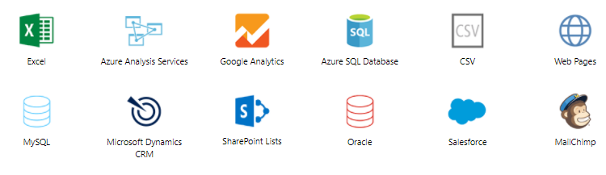

**Collaboration — Sharing Work With Your Team**

Collaborative capacity is created through the use of means to import data from different sources with different structures, exchange reports and perspectives amongst participants.

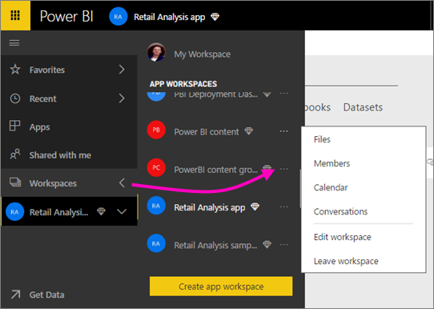

Data is collected from different departments within the organisation and from external data. Some useful tools include Power Query that extracts and transforms details, Power Pivot which models and analyses, and Power View and Map for visualising data. This next-generation tool consolidates all the tools mentioned above and eliminates dependence on Excel and Office.

**Education and Training — Mastering The Software**

The programme is highly intuitive, particularly for users of Microsoft. But if you encounter any roadblocks, Microsoft provides a productive learning environment:

the Documentation section gives users and developers access to Get Started Tutorials for each available product, as well as dashboards and content packs to jump-start your analysis with the tool.

Guided Education is a series of courses separated into subjects that literally grasp the strengths of the text and video guides.

**Importance of SAP B.I ?**

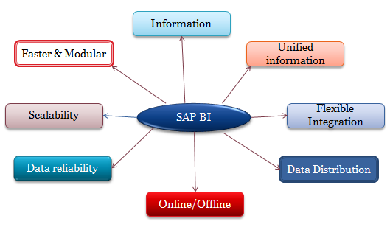

**SAP B.I - Information at fingertips**

SAP BI presents the client with the full data in a simplified form, so that it can be easily understood. It's much easier to search for critical information and gain valuable insight in this manner. And this is achieved using common business words, rather than using abstract symmetrical concepts.

**SAP B.I - A unified information system**

For SAP BI, the company does not have to manage two separate systems for BI and ERP. Both SAP BI and ERP programmes are easily integrated and operate on one server. This incorporates built-in performance optimization tools and a robust life cycle that assists leadership.

**SAP B.I - allows for flexible integration and interoperability**

With SAP BI and SAP BW, the company can combine multiple business apps and systems such as accounting, HRm sales to render them simple and accessible for the consumer. Users may collect data from any particular department independently in conjunction with SAP BI.

**SAP B.I - Large Scale Data Distribution**

Through SAP BI, a company will transmit information to hundreds of thousands of people. The printing and planning capability of SAP BI allows the efficient distribution of large volumes of qualified BI material to a number of employees and end users. You may share information from BI through email and other platforms while retaining protection.

**SAP B.I - always works, whether one is online or offline**

Through online or offline, SAP BI is always accessible via plugins, apps, computer widgets or mobile devices. Now everyone can be linked to a company server with the latest SAP software solutions.

**SAP B.I - always reliable**

SAP Business Intelligence is extremely reliable since information can be obtained safely and securely and combined with the MS office environment.

**SAP B.I - Easy and painless scalability**

SAP Business Intelligence is extensible thanks to its service-oriented architecture. A company can increase or decrease its SAP BI capability in compliance with business requirements. One may launch SAP BI for a single project and extend to the entire organisation.

**SAP B.I - Faster, Modular Development**

SAP Business Intelligence operates with enterprises of any scale – from small businesses to large Fortune 500 corporations boasting multi-billion dollar sales.

**Why do we need Data Warehouse & BI ?**

Organizations include various types of data, such as accounting, human resources, clients, manufacturer information, etc.which can be housed in different types of storage containers, such as DBMS, Excel files, SAP R/3 systems, etc. Even the internal business data is often allocated throughout many different systems and are not especially well configured.

**What makes SAP BI more effective BI tool?**

* Single point of access to all information is possible through BI. The data from various sources can be accessed at the single place(i.e BI).
* Data collected from various sources are presented in the form of reports which is efficient for analysis of the data at a high level.
* SAP BI provides easy to use GUI and better formatting
* Some of the key functionality that makes SAP BI better than rest is its ability to analyze **multidimensional** data sources in both web and MS office environments, flexible dashboards, mobility and a flexible, scalable BI platform.
* SAP BI is known for its awesome **query performance**, while requiring little administration
* **Mobile BI** for end users on the go
* **Easy Integration** with other platforms

|  |  |  |
| --- | --- | --- |
|  | **OLTP Systems (Operative Environment)** | **DWH/OLAP Systems(Informative Environment)** |
| **Target** | Efficiency through automation of business processes | Generating Knowledge  (Competitive Advantage) |
| **Priorities** | High availability, higher data volume | Simple to use, flexible access to data |
| **View of Data** | Detailed | Frequently aggregated |
| **Age of Data** | Current | Historical |
| **Database operations** | Add, Modify, delete, update and read | Read |
| **Typical data structures** | Relational(flat tables, high normalization | Multidimensional Structure |
| **Integration of data from various modules/applications** | Minimal | Comprehensive |
| **Dataset** | 6-18 months | 27 years |
| **Archiving** | Yes | Yes |

### Conclusion

This report discusses the benefits and drawbacks of using application software as a mechanism for business processing. This report will also discuss with specific examples and the key features of business intelligence functionality. It also compares the tools and techniques associated with business intelligence functionally.

Power BI offers the company with excellent visual analysis tools as a business intelligence device. With the right data and platform, it can be an excellent fit in your effort to use data to increase the efficiency and productivity of your organisation. Nonetheless, we also support the need to experiment with different methods before pledging (i.e. purchasing) licences or long-term contracts.